# Gear IAP Web App Development

Contents

Gear IAP Web App Development 1

Gear IAP Web App Development using Tizen Studio. 2

Pre-Requisite: 3

Create New Tizen Project 3

Modify config.xml for IAP 3

Modify index.html for screen design 4

Modify app.js 7

Register items in Samsung Seller office 9

Add image resources 10

# Gear IAP Web App Development using Tizen Studio.

## Pre-Requisite:

1. PC with Tizen studio setup
2. Gear Watch
3. Android Mobile
4. The Gear device must be connected with a host device through a Samsung Gear application.
5. Application API version must be at least 2.3.2 in config.xml file.

## Create New Tizen Project

1. Click File -> New -> Tizen Project

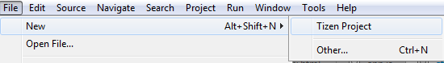

1. Select Template click Next

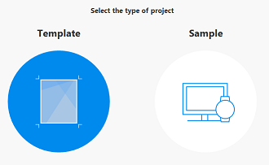

1. Select as below and create your project.



## Modify config.xml for IAP

App must meet below mandatory permissions for IAP.

<tizen:privilege name=*"http://tizen.org/privilege/billing"*/>

config.xml will look like as below after these modification

<?xml version=*"1.0"* encoding=*"UTF-8"*?>

<widget xmlns:tizen=*"http://tizen.org/ns/widgets"* xmlns=*"http://www.w3.org/ns/widgets"* id=*"http://yourdomain/TAUBasic"* version=*"1.0.0"* viewmodes=*"maximized"*>

<tizen:application id=*"yzS7eWkYsp.IAPWebinar"* package=*"yzS7eWkYsp"* **required_version=*"2.3.2"***/>

<content src=*"index.html"*/>

<feature name=*"http://tizen.org/feature/screen.size.normal"*/>

<icon src=*"icon.png"*/>

<name>IAPWebinar</name>

**<!-- privilege added for IAP support -->**

**<tizen:privilege name=*"http://tizen.org/privilege/billing"*/>**

<tizen:privilege name=*"http://tizen.org/privilege/application.launch"*/>

<tizen:profile name=*"wearable"*/>

<tizen:setting background-support=*"disable"* encryption=*"disable"* hwkey-event=*"enable"*/>

</widget>

## Modify index.html for screen design

## Application screens are drawn inside this html file.

1. Welcome Screen  
   
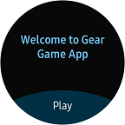

<!-- WELCOME -->

<div class=*"ui-page ui-page-active"* id =*"welcome"*>

<div class=*"ui-header"*>

<h2 class=*"ui-title"*></h2>

</div>

<div class=*"ui-content"*>

<div class=*"welcome-title"*>Welcome to Gear Game App</div>

</div>

<footer class=*"ui-footer ui-bottom-button"*>

<a id=*"play_btn"* class=*"ui-btn"*>Play</a>

</footer>

</div>

2. Game Screen

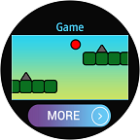

<!---- GAME ---->

<div class=*"ui-page"* id=*"more"*>

<div class=*"ui-header"*>

<h2 class=*"ui-title"*>Game</h2>

</div>

<div class=*"ui-content"*>

<div> <img class =*"game-img"* /> </div>

</div>

<footer class=*"ui-footer ui-bottom-button"*>

<img id=*"more_btn"* class =*"more-img"* src=*"/image/more_img.png"*/>

</footer>

</div>

3. ItemList Screen

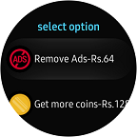

<!---- ITEM LIST ---->

<div class=*"ui-page"* id=*"optionList"*>

<div class=*"ui-header"*>

<h2 class=*"ui-title"*>select option</h2>

</div>

<div class=*"ui-content"*>

<ul class=*"ui-listview"*>

<li class=*"li-has-thumb-left"* id =*"idRemoveAds"*>

<img src=*"/image/remove_add.png"* class=*"ui-li-thumb-left"* >

<div class=*"ui-marquee"* id=*"remove-ads-text"*></div>

</li>

<li class=*"li-has-thumb-left"* id =*"idMoreCoins"*>

<img src=*"/image/more_coins.png"* class=*"ui-li-thumb-left"*>

<div class=*"ui-marquee"* id=*"get-more-coins-text"*></div>

</li>

<li class=*"li-has-thumb-left"* id =*"idUnlockNewLevel"*>

<img src=*"/image/unlock_level.png"* class=*"ui-li-thumb-left"*>

<div class=*"ui-marquee"* id=*"unlock-new-level-text"*></div>

</li>

</ul>

</div>

</div>

4. Buy Screen

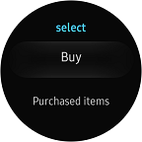

<!-- Buy -->

<div class=*"ui-page"* id=*"buy"*>

<div class=*"ui-header"*>

<h2 class=*"ui-title"*>select</h2>

</div>

<div class=*"ui-content"*>

<ul class=*"ui-listview"*>

<li class=*"li-has-singleline"* id =*"buy_btn"*>

Buy

</li>

<li class=*"li-has-singleline"* id=*"purchase_btn"*>

Purchased items

</li>

</ul>

</div>

</div>

## Modify app.js

The core logic of the app is written inside this class.

1. Item List can be fetched using below API :

**function** onGetItemList() {

webapis.inapppurchase.getItemList(1, 20, "ALL", IAPmode, getItemsuccessCallback, getItemeErorCallback);

}

Here IAPmode is “IAP_SUCCESS_TEST_MODE”.

2. Items are purchased using blow API :

Non Consumable Item:

**function** onByNonConsume() {

webapis.inapppurchase.startPayment(remove_ads, IAPmode, purchaseSuccessCallback, purchaseErrorCallback);

}

Consumable Item:

**function** onByConsume() {

webapis.inapppurchase.startPayment(more_coin, IAPmode, purchaseSuccessCallback, purchaseErrorCallback);

}

Subscription item:

**function** onBySubs() {

webapis.inapppurchase.startPayment(unlock_level, IAPmode, purchaseSuccessCallback, purchaseErrorCallback);

}

3. Purchased Item List can be fetched using below API :

**function** onGetPurchasedItems() {

webapis.inapppurchase.getPurchasedItemList(1, 15, **new** tizen.TZDate(2017, 06, 1), **new** tizen.TZDate(2019, 06, 01), purItemSuccessCallback, purItemErrorCallback);

}

For more info regarding API refer following link:

<http://img-developer.samsung.com/onlinedocs/gear/web_device/webapis/iap.html>

## Register items in Samsung Seller office

1. Log in to Samsung seller portal (<https://seller.samsungapps.com>).

2. Add your application by selecting application type as Gear.

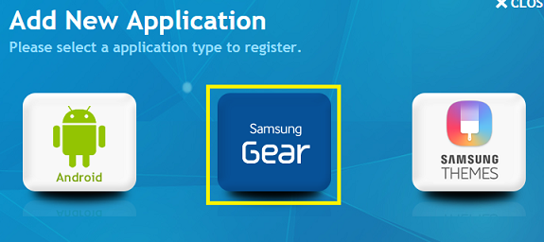

3. Register your items in In App purchase section.

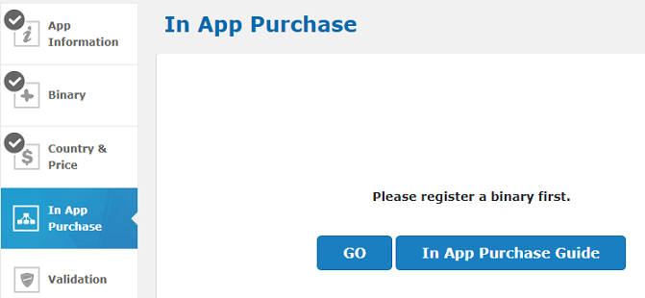

4. For more details download In-App purchase guide from seller portal.

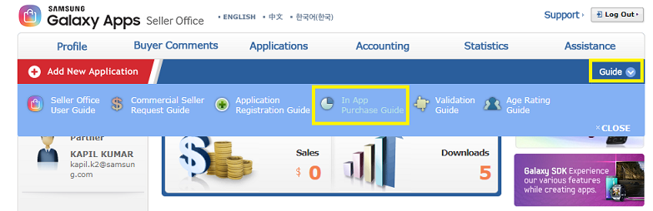

## Add image resources

Below attached images are used for application screens.

